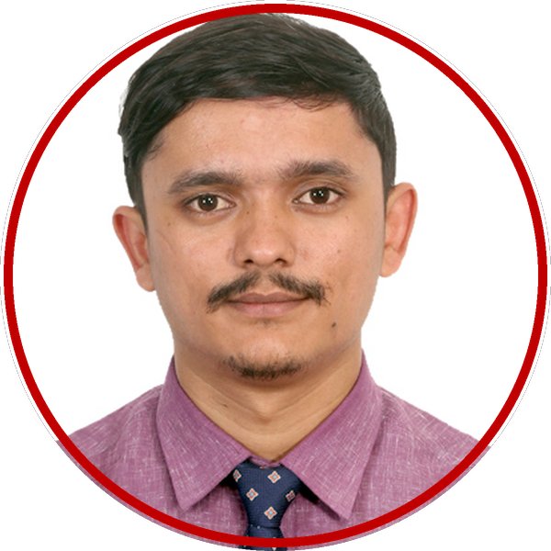 | HIKMAT BAHADUR SAUD  MBA IN GLOBAL LEADERSHIP  MBA student with more than four years of client-facing sales and consulting experience, pairing strong communication and time management with a record of exceeding targets and building lasting relationships.
CONTACT  Email Address:  saudhikmat19xx@gmail.com (Professional)  hsaud@upei.ca (Academic)  Location:  Charlottetown, PE  LinkedIn:  www.linkedin.com/in/hikmat-bahadur-saud-849a853b0  AREAS OF INTEREST  - Finance  - Consulting  - Sales & Marketing  - Customer Relations  - Hospitality Operations  SKILLS  - Microsoft Office (Word, Excel, PowerPoint)  - Communication & Presentation  - Relationship Building  - Time Management  - Attention to Detail  GEOGRAPHIC PREFERENCE  - Local (PEI)  - Remote  LANGUAGES  - English (Fluent)  - Nepali (Native)  - Hindi (Conversational)  ACHIEVEMENTS  - IELTS Academic 8.0 overall (Jan 2026)  - Winner, TU BBA Cup 2020: team placed first among 18 campuses  - Winner, Product Knowledge Quiz, Pharmonics Life Sciences (20 participants) | PROFILE  I am a first-year MBA in Global Leadership student at UPEI. I bring strengths in communication, relationship building, and time management, developed over four years in client-facing roles. As a Professional Sales Representative at Pharmonics Life Sciences, I built relationships with 100+ doctors and 200+ pharmacies monthly and consistently exceeded sales targets. As a Liaison Officer at KTM Consulting Group, I supported student follow-ups, engaged visiting university representatives and guided about 50 students through IELTS Academic testing. I aspire to become a financial analyst, and at Flip The Fair I am eager to explore opportunities in finance, consulting and customer relations. Fun fact: I managed the team that placed first among 18 campuses at Nepal’s TU BBA Cup.  EDUCATION  MBA in Global Leadership Expected graduation: SEP 2028  McDougall Faculty of Business, University of Prince Edward Island  Bachelor of Business Administration AUG 2022  Tribhuvan University, Mahendra Multiple Campus, Dharan, Nepal  EXPERIENCES  Digital Fulfillment Team Associate (Part-Time) SEP 2026 – PRESENT  Walmart OMNI Department, Charlottetown, PEI  - Picking and packing customers’ online grocery orders with a handheld device, bringing them out to vehicles or the pickup counter in all weather, and providing friendly customer service along the way.  Liaison Officer AUG 2024 – AUG 2026  KTM Consulting Group, Kathmandu, Nepal  - Organized monthly internal meetings and prepared reports for the branch manager, supporting operational adjustments and timely student follow-ups.  - Represented the organization at meetings and public events and engaged visiting university representatives, supporting relationships with partner institutions.  - Guided approximately 50 students through IELTS Academic testing, achieving an average score of 6.0, with 10 students scoring above 8.0.  Professional Sales Representative MAR 2022 – JUL 2024  Pharmonics Life Sciences Pvt. Ltd., Dharan, Nepal  - Built trust-based relationships with 100+ doctors, 200+ pharmacies and 3 teaching hospitals each month by scheduling regular visits and meetings.  - Exceeded sales targets throughout employment by planning and prioritizing daily visits, reaching a peak of 120% of target in the second year.  - Expanded the company’s network of healthcare contacts in the Dharan area through consistent follow-up and relationship building.

